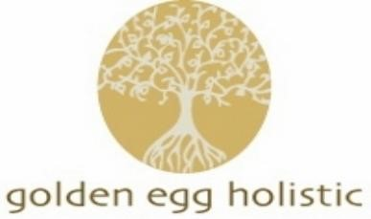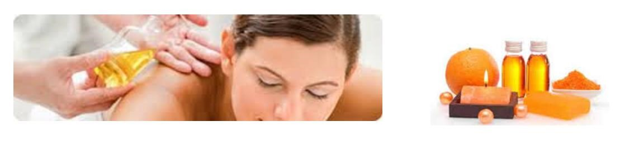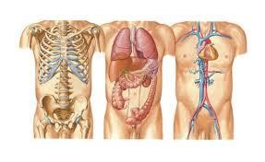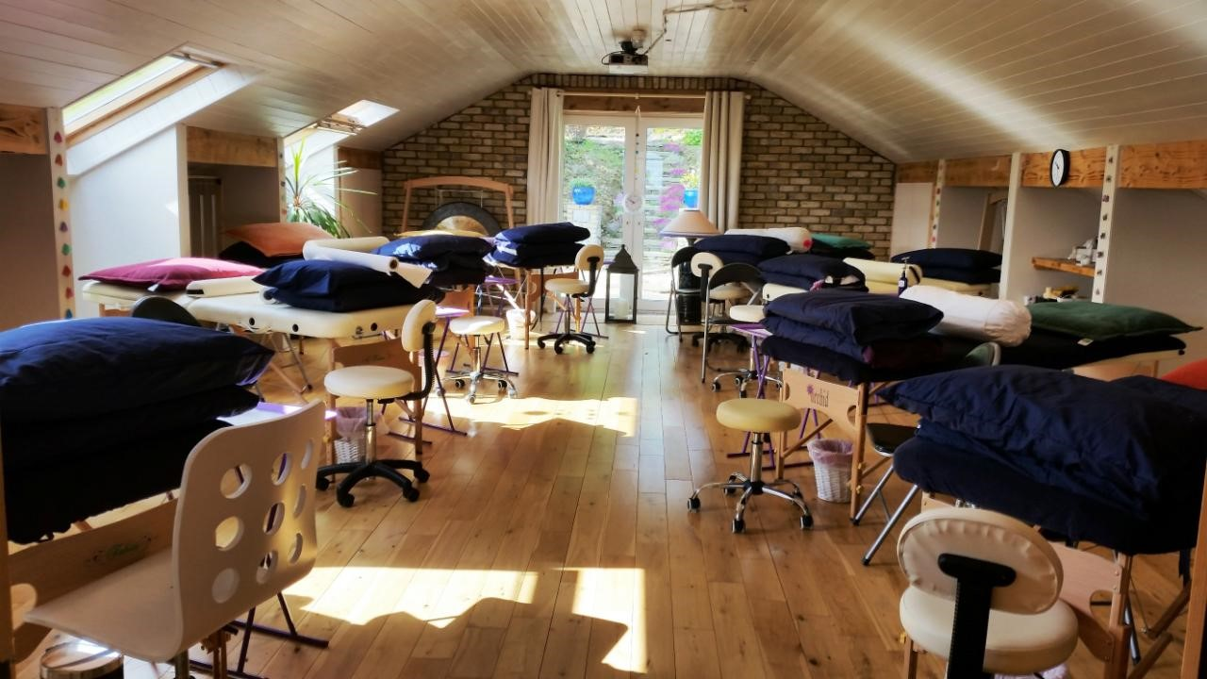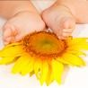
Centre of Excellence for Diploma and Post Graduate Training
Why choose Golden Egg Holistic?
Golden Egg Holistic is a centre of excellence for both practitioner ​ Diploma and Post Graduate training.
​ ​
​ At Golden Egg, we strive to inspire our students with the very best of what complementary therapies have to offer, for both the beginner, and the experienced therapist. In addition to our professional practitioner diploma courses, we also offer an extensive and specialised range of ​ post graduate
​ and CPD​ (continual professional development) workshops. Golden Egg is the only Irish training school which offers many of these new and exciting workshops.
Our trainers are well established ,​ highly qualified , experienced , competent in and genuinely passionate about their specialities. Our trainers are also working therapists.
​ We are very privileged to host many world leading Complementary Therapy Trainers at Golden Egg.​
Complementary medicine is a rapidly growing and evolving industry and our training programmes reflect these changes. We keep up to date with current research and training standards, adapting and progressing our methods and techniques to match.
​ Our training programmes are certified and approved by a range of Internationally recognised examination boards and Holistic Therapy Associations including ITEC, FHT, IRI, IMTA, CTHA, AAOR, AOR, etc
​
Golden Egg Holistic ​ offers the invaluable skills that will help you develop, not only as an individual, but as a professional in your future career as a therapist. Our Holistic, Educational and professional approach to teaching ensures a rewarding and fulfilling (And enjoyable!) ​ learning experience.
​ Please do not hesitate to contact us with any questions you may have. ​
Catriona Plunkett
(School Principal)
ITEC Diploma in Holistic Massage Diploma
Including:
- Anatomy, Physiology and Pathology
- Business, Finanace, Health and Safety
- Covid /Infection control and prevention

January to July 2024 (See timetable for dates)
Holistic Massage(also known as Swedish Massage) is the practical application of a full body massage using all of the classical movements and theory for same. As well as full body massage, you will also learn neck & shoulder massage, foot massage, hand and facial massage.
Adopting to each technique and maintaining good posture throughout a massage treatment is of great benefit to a Massage therapist, therefore we give emphasis on posture during this training. Good posture while working will strengthen the therapists body instead of causing strain.
Massage is no longer just considered a ‘pampering’ treatment for many people. Research has proven Massage effective in so many ways for so many different ailments and conditions including stress and anxiety, back pain, migraine, fertility, digestive disorders, oedema, soft tissue strains and injuries, Arthritis, Cerebral Palsy, Autism, side affects to cancer treatments etc.
From premature babies, toddlers, teenagers, Pregnant women, cancer patients and the eldery, Massage and Touch therapies have been proven to have many fantastic benefits.
On successful completion of this course, the student will be fully qualified to confidently begin working as a Massage Therapist. An Holistic Massage diploma is also the perfect foundation course for those who would like to further their knowledge and specialise in different areas of Massage and Bodywork such as Pregnancy Massage , Baby Massage, Fertility Massage, Pediatric Massage, Story Massage,Sports Massage, Deep Tissue Massage, Myofascial Release, Massage for people living with Cancer, Lymphatic Drainage Massage etc

ITEC Diploma: Anatomy, Physiology & Pathology
It is essential for Therapists to have a sound understanding of Anatomy and Physiology, as they will be working in direct contact with the body structures. It is also vital that they have a comprehensive knowledge of diseases and disorders of the human body so that they are aware of when and when not to treat a client and only operate within certain parameters This fascinating course provides students with a thorough understanding of anatomy and physiology of the body so that they have a complete knowledge of the structure and functions of each area on which they are working.
*This module is taken online through pre recorded tutorials, so students can watch over and revise as much as they need. There are hundreds of quiz questions and sample papers to revise through which are graded automatically and can be taken repeatedly
Tutorials covering all systems of the body and their related pathologies.
- Cells: organization, metabolism, responsiveness, growth, repair and reproduction; cell structure and function.
- Tissues: epithelial, connective, muscular and nervous tissue; tissue repair and conditions affecting it.
- The Integumentary System: the functions of the skin; the epidermal, dermal, subcutaneous skin layers; common skin diseases and allergies.
- The Skeletal System: the development and structure of bone cells; the structure, location and functions of the bones and joints; surface anatomy; the spinal vertebrae; common skeletal disorders.
- The Muscular System: skeletal, smooth and cardiac muscle, its structure and functions; muscle contraction; origin and insertion; muscle fatigue; tendons and ligaments; common diseases of the muscular system.
- The Nervous System: the structure and functions of neurons and glial cells; synapses; the structure and functions of the brain and spinal cord; the limbic system; sensory reception and adaptation; the autonomic nervous system; common diseases of the nervous system.
- The Special Senses: the structure and functions of the special senses: hearing, sight, taste, touch and smell; the process of olfaction; sensory disorders.
- The Endocrine System: the functions of the endocrine system; homeostasis; the principal glands and hormones; common diseases of the endocrine system.
- The Cardiovascular System: the composition and functions of the blood; blood disorders; the structure and functions of the heart; common heart diseases; the principal arteries and veins; vascular disorders.
- The Lymphatic System: the structure and functions of the lymphatic system; lymph nodes and lymphatic tissue; common diseases of the lymphatic system.
- The Immune System: specific immunity and nonspecific defence mechanisms; antigens and antibodies; inflammation; the allergic response; immune disorders.
- The Respiratory System: major respiratory structures; the structure and functions of the lungs; external and internal respiration; common respiratory diseases
- The Digestive System: the structure and functions of the digestive system; ingestion, digestion, absorption and elimination; the small and large intestines; common diseases of the digestive system.
- The Urinary System: the structure and functions of the urinary system, kidneys and nephrons; water and electrolyte balance; common urinary diseases.
- The Reproductive System: the structure of the male and female reproductive systems; male and female sex hormones; the menstrual cycle; the stages of pregnancy; common diseases of the reproductive system.

ITEC Diploma: Anatomy Unit 22 Professional Conduct and Business Awareness
The Unit 22 Professional Conduct and Business Awareness module will give the student confidence that they are working legally, ethically and professionally within the professional model. Subject areas covered include the necessity of having professional indemnity insurance, keeping client records, client confidentiality, clienttherapist relationship, first aid, Advertising, Code of Ethics, Continual Professional Development, Accounting Systems, Stock control, Basic Principles of selling, Employer responsibilities , Networking, Health and Safety, Date Protections act, etc

ITEC Diploma: Covid /Infection prevention and control
This new exam module ensures students understand the necessary infection prevention methods required within their working environments in order to maintain high standards of health and safety in the provision of their services to clients. A separate certificate is issued for this module. The aim of this unit is to develop the learner’s knowledge and understanding of how to prevent the spread of COVID-19 and other infections, and how to work safely. Learners will develop knowledge on the importance of social responsibility, the causes, transmission and effects of COVID-19, and the methods used to control transmission, such as correct hand hygiene and the use of Personal Protective Equipment. They will also gain an understanding of the safe working practices required to protect themselves and their clients.
**If you already have an ITEC qualification which exempts you from Anatomy & Physiology (if qualification is less than 3 years old) and/or Unit 22 Business Awareness, a discount will be exempt from repeating these modules.
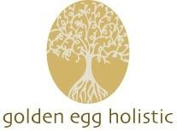
ITEC Holistic Massage Diploma -Course Fees and Payment Plans
Holistic Massage Diploma (including Anatomy, Physiology& Pathology Diploma) Course Fee: €1700 Plus Exam Fees (exam fee currently €200)
Payment Plan :
Booking Deposit €500
Feb 1st €400
March 1st €400 April 1st €400
Installments are paid by online accounts system. Payments are non refundable and non transferable.
*Exam fees are due 12 weeks before exam date. Exam registration cannot be completed without full payment of course fees and exam fees.
Holistic Massage Diploma (without Anatomy, Physiology& Pathology Diplomafor those with existing up to date Anatomy qualification )
Course fee: €1500 Plus Exam Fees(exam fee currently €200)
Payment Plan :
Booking Deposit €500
Feb 1st €400
March 1st €400 April 1st €200
Installments are paid by online accounts system. Payments are non-refundable and non -transferable.
*Exam fees are due 12 weeks before exam date. Exam registration cannot be completed without full payment of course fees and exam fees.
.

List of materials needed for Holistic Massage Diploma course
The equipment that you will need is minimal and includes:
- Large ring binder folder to hold A4 Sheets (for Case studies)
- A4 Clip Board • Pens and paper .
- Antibacterial wipes
- Hand sanitiser
- Nail file
- Massage Oil
- 2 Bath Sheets, 2 Bath towel and 1 hand towel -All Navy (or any dark colour)
- 1 Couch cover- Navy (or any dark colour)
- 2 pillows
- 2 pillow covers-Navy or any dark colour
- Professional Therapist Uniform to be worn to all Massage classes:
Black trousers (No jeans, leggings), Therapist Tunic , fully covered low heeled shoes, black socks.
- Course Books:
An Introductory guide to Anatomy, Physiology ‘ by Louise Tucker (latest edition)-A&P Students only.
An Introductory guide to Massage’ by Louise Tucker (latest edition)
For Therapist equipment and supplies, we recommend the following suppliers (some of which will offer you a discount on as a student of Golden Egg Holistic (contact suppliers directly re discount offers):
www.bomar.ie
www.buttercupsuniforms.com www.happythreads.ie
www.flyingwild.ie
Student Therapist Insurance is a legal requirement when carrying out client treatments as part of your Case studies - not needed until you start Case Studies. We recommend Brian Mullins insurance or Balens insurance.
Requirements for Students to be awarded Certificates:
- A 100% commitment is required from all students
- Students must be available for all classes. If attendance falls below 90% or your trainer recommends a student is not ready, you may not be permitted to sit exams.
- If any class time is missed, it is the responsibility of the student to cover what they have missed. You may also be given extra assignments to cover material missed in class.
- Completion and submission of 20 Hours of Holistic Massage Case Studies
- One hour multiple choice ITEC Theory examination paper in Holistic Massage-50 questions
- One hour multiple choice ITEC Theory examination paper in Anatomy & Physiology- 50 questions (unless already completed in previous 3 years)
- One hour multiple choice ITEC Theory Professional Conduct & Business Awareness examination paper- 50 questions (unless already completed in previous 3 years )
- 30 question multiple choice ITEC Theory examination paper in Covid Infection Control
- One hour practical massage examination by external ITEC examiner including a short oral examination
- Course assignments completed on time
- Course fees paid in full
If you have any questions on any of the above, please contact Catriona Plunkett (School Principal). Email: info@goldeneggholistic.com Ph: 087 6011797

Terms and Conditions
Time Keeping & Attendance:
Students are asked to arrive on time and ready for class and are expected to attend all classes on the timetable. Regular attendance records are issued to ITEC.
If class attendance falls below 90%, students may be required to repeat the course in full, at the students own cost.
If you are going to arrive late or miss a class, please text/call in advance .
Student Conduct: Students are expected to behave professionally and respectfully at all times towards their fellow students and trainers. Please read and make yourself familiar with the ‘Code of conduct’ document
Course Fees: If a student does not complete the training in full, the full course fee is still payable.
Assignments: Class assignments should be handed in on time, fully completed.
Case Studies: Case studies (Holistic Massage & Reflexology students only) are due, fully completed, by the deadline given.
Email address and PC Skills: All students need a working email address. Please check your email regularly as class notes, invoices and updates will be emailed to you. If you change your email address, please notify us so we can update our records.
We recommend having a PC or Laptop (or access to one) plus a basic level of PC skills to type up your class assignments and case studies.

Code of Conduct
The following represents the minimum requirement regarding acceptable Code of Conduct. It applies to all Students. If a student can demonstrate that any part of this Code of Conduct is prejudicial to good therapeutic practice in their particular therapy they may apply to the Golden Egg school principal (Catriona Plunkett), in writing, for special dispensation. The decision on any application will be a matter of record and is final. All members are encouraged to uphold the codes of conduct laid down by his/her own therapy Association/Register.
- Students shall have respect for the religious, political, spiritual and social views of any individual irrespective of creed, sex, colour or race.
- Students shall always conduct themselves in an honourable manner and with diligence in their relations with patients/clients and the public 3. Students and Qualified Therapists should explain fully to the patient/client either verbally (or in writing if necessary) the procedures involved in the treatment or treatments and should include questionnaires, length and possible number of consultations, likely content, fees, etc. before embarking on treatment with a patient/client.
- Students /Qualified Therapists should not be judgemental and should recognise clients right to refuse treatment or to choose to ignore advice.
- Students / Qualified Therapists should keep comprehensive records of treatments, dates and advice given for at least 5 years. This is necessary should any claims of negligence arise and it is good and efficient practice. It would be for the member to show that any record can demonstrate that whatever treatment was undertaken it was reasonably administered and competently undertaken.
- Students /Qualified Therapists should be aware of the Data Protection Act and must comply with it.
- Students and Golden Egg staff have a duty to keep records of all attendances, information, records and notes about a patient/client entirely confidential. Disclosure should not be made to any 3rd party including a member of the patient/client’s own family without the patient/client’s consent unless it is required by due process of the law, Statute, Statutory instrument, court order or otherwise.
- Students and Qualified Therapists should ensure their working conditions are suitable for the therapy or therapies that they practice.
- Students and Qualified Therapists must be adequately insured to practice and must provide evidence of this to the client and also to Golden Egg staff if/when requested.
- No 3rd party, assistants or members of the patient/client’s family should be present during the course of a consultation with an adult, unless the express permission of the patient/client is granted.
- The relationship between a Students /Qualified Therapists and patient/client is that of a professional. It is the member’s duty not to abuse the trust of care, integrity and skill placed in him/her by a patient/client.
- A Students/ Qualified Therapists attitude towards a patient/client should be positive and hopeful thereby uplifting the patient/client’s mental outlook and belief in a progression towards good health practice.
- Students and Qualified Therapists should never claim to “cure” and “recovery” should not be guaranteed. The possible therapeutic benefits may be described.
- Proper moral conduct should always be paramount in a Therapists relationship with a patient/client and a member should behave with courtesy, dignity, respect, tact and discretion.
- Students and Qualified Therapists must not enter into a sexual relationship of any kind with a patient/client and should guard against any act, statement or suggestion that may be interpreted (mistakenly or otherwise) as having a sexual implication.
- Students and Qualified Therapists should seek a good relationship and shall work co-operatively with other healthcare professionals and respect and recognise their contribution within the healthcare profession.
- Students and Qualified Therapists visiting hospitals and nursing homes should comply with the rules and regulations laid down by those institutions and take into account visiting times and the need of medical personnel.
- Students and Qualified Therapists should not diagnose, treat or perform tests on animals unless specifically qualified to do so nor should they give advice after diagnosis by a veterinary surgeon nor should a member contradict or countermand his/her instructions
- Students and Qualified Therapist should not use manipulation or vigorous massage unless they have the appropriate professional qualification.
- Students and Qualified Therapists should advertise in a dignified way and should not include any testimonials that claim to “cure” any disease.
- Students will abide by the decisions made under the Complaints and Disciplinary Procedures.

ITEC HOLISTIC MASSAGE DIPLOMA -BOOKING FORM 2024
Please do not delay booking as there is a limited number of places for this course. Your place is not confirmed until compted booking form and deposit have been received.
Name:Uka Faith Okpara.............................................................................................
Address: ..52 lakeside garden kilminchy portlaoise R32 CH2K ...........................................................................................
Tel No: ....0894217494...........................................................................................
Email: .kosookpara@yahoo.co.uk................................................................................................
Please tick the option applicable to you:
I would like to apply for Holistic Massage Diploma (with Anatomy, Physiology& Pathology) yes
I would like to apply for Holistic Massage Diploma (without Anatomy, Physiology &Pathology) no
I have read, understood and agree to abide by the college terms and conditions yes
Date of Birth 04 09 1972
ITEC Number (if applicable)
Signature: ………………………ufokpara…...............................................................
*If you have an existing ITEC (or QQI) qualification in Anatomy, Physiology and Pathology and / or Unit 22 Business awareness qualification, please include a copy of your certificate with your application.
Please post/email in your completed booking form with your deposit to:
Catriona Plunkett. Golden egg holistic, Glenfield, Portlaoise, Co.Laois R32PH0A

